SYED MASHOOD ADNAAN
2303A54059
Batch-47_B
Lab 1
Assignment Number 1.3

TASK:1
PROMPT: Generate a Python program that asks the user for an integer n and prints the Fibonacci sequence up to n terms, implementing all logic directly in the main code without using any user-defined functions.
TASK:2
PROMPT: Optimize the code
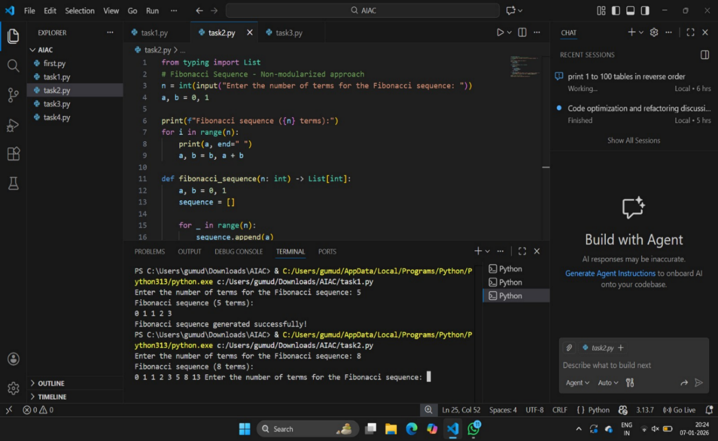
TASK:3
PROMPT: Write a Python program that uses a function to print the Fibonacci sequence and asks the user for a number
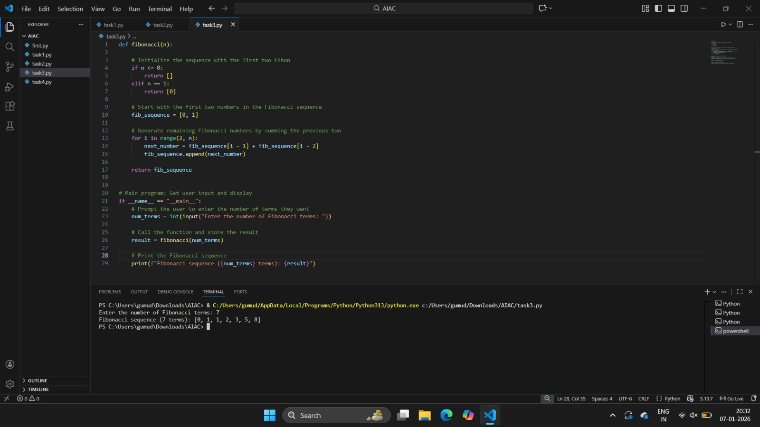
TASK:4
PROMPT: Print Fibonacci code with functions and without functions
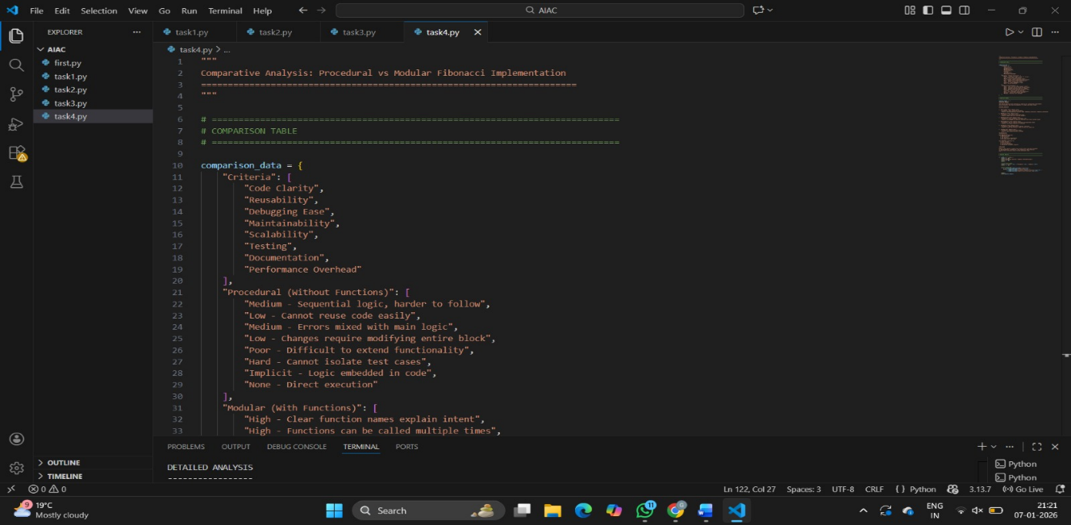
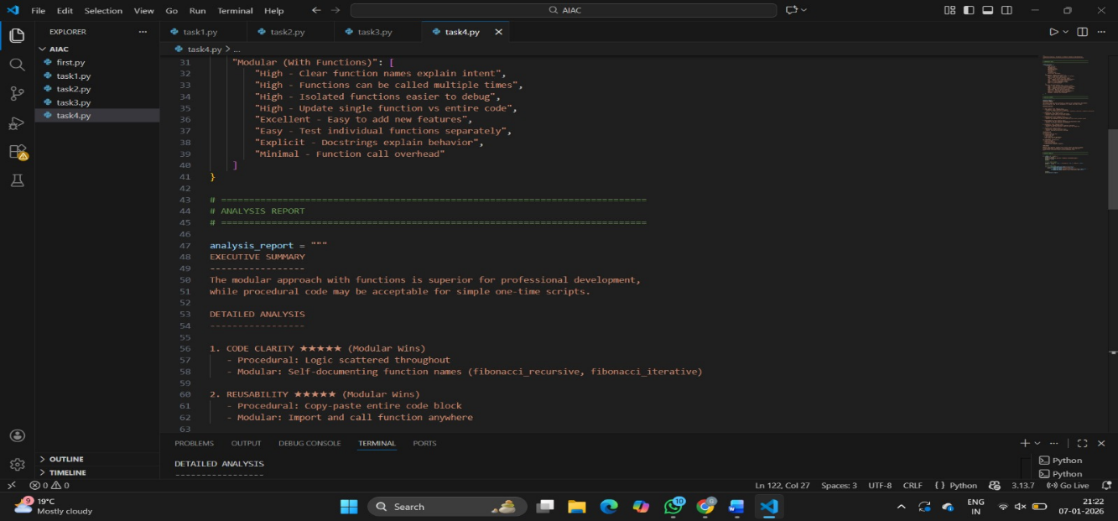
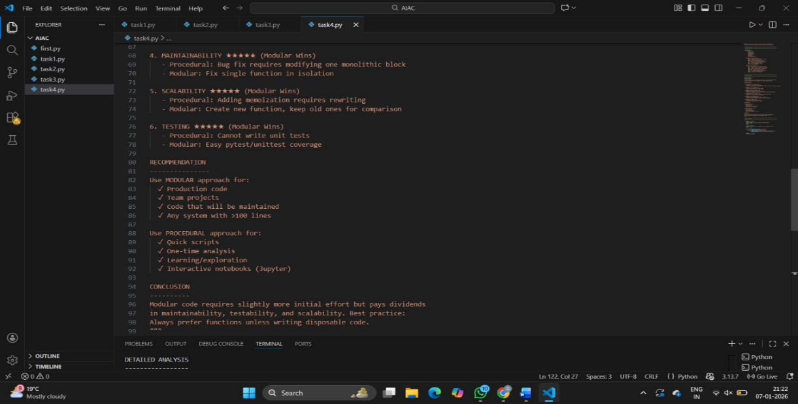
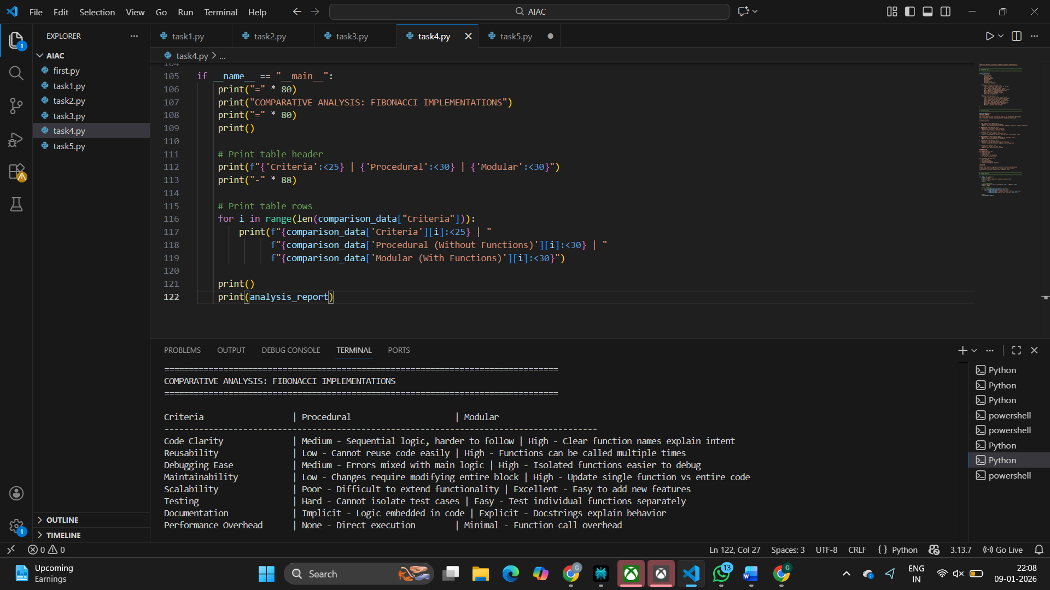

TASK:5
PROMPT: Generate an iterative Fibonacci implementation and a recursive Fibonacci implementation. Compare their time complexity and performance for large n
